User Manual

After you have successfully installed all prerequisites and ran the application in the localhost url you should be prompted with the login screen. The main options are to login, and recover your password. If you take a look into the instructions file you will find some sample users of each kind to test the application.

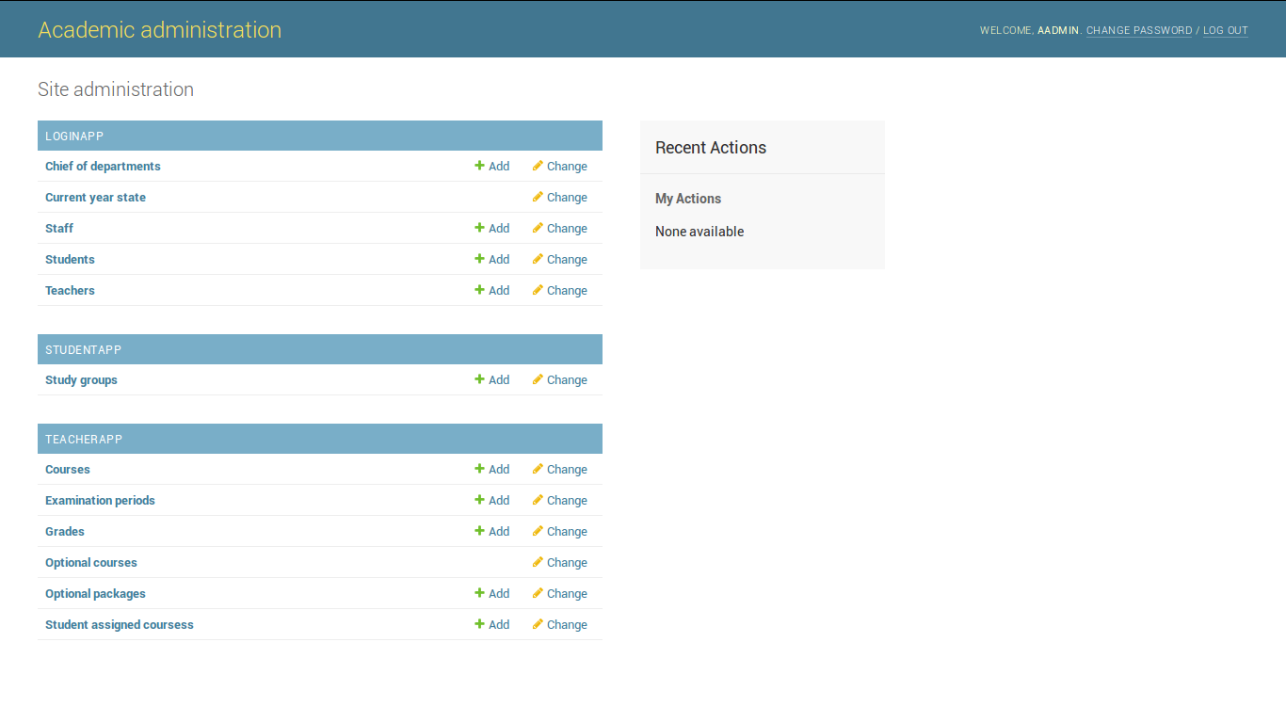Firstly if you login as an administrator you will be redirected to a screen like this one:

The top right corner shows you the possibility to change your password using different types of validations for input.

As you can see the main possibilities as an administrator are to compute crud operations on main entities but also to change the state of the current year so that other events can take place in normal order.

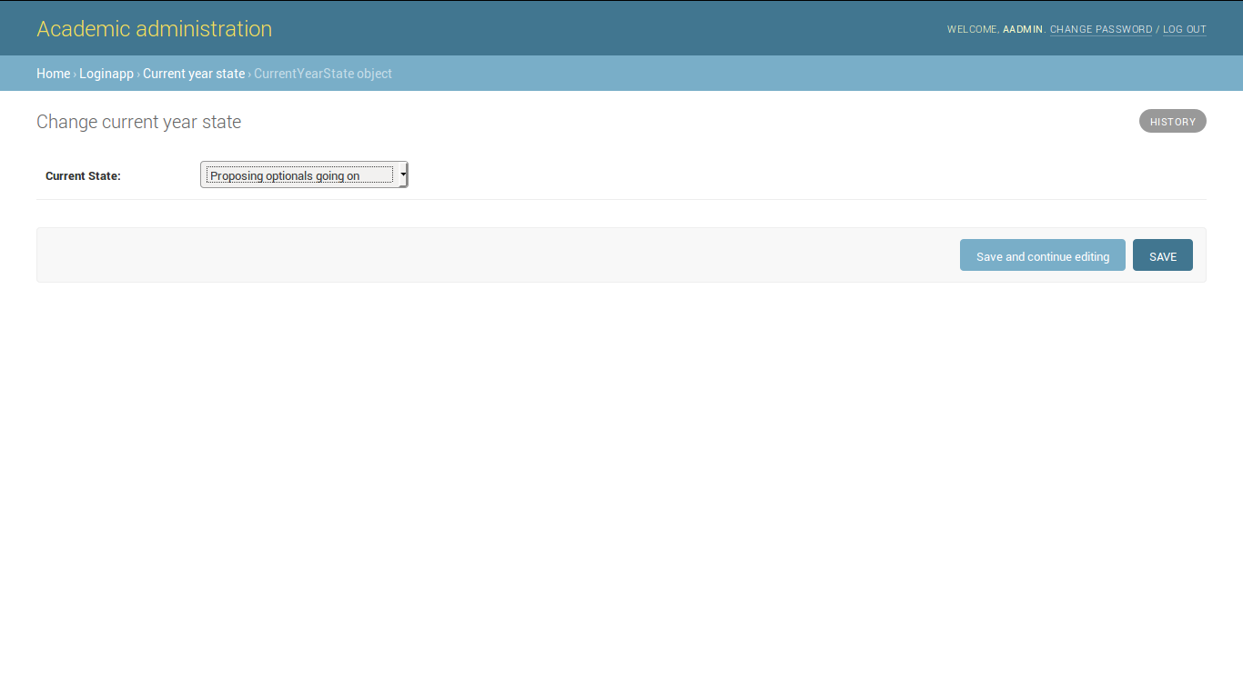

Also as an administrator you can go to Study group to select an action to download statistics by group, by year or even by interval

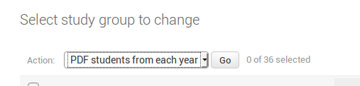Next, you can also login as a teacher from where you can see the courses you are teaching and also to see the students enrolled to give them grades as bellow :

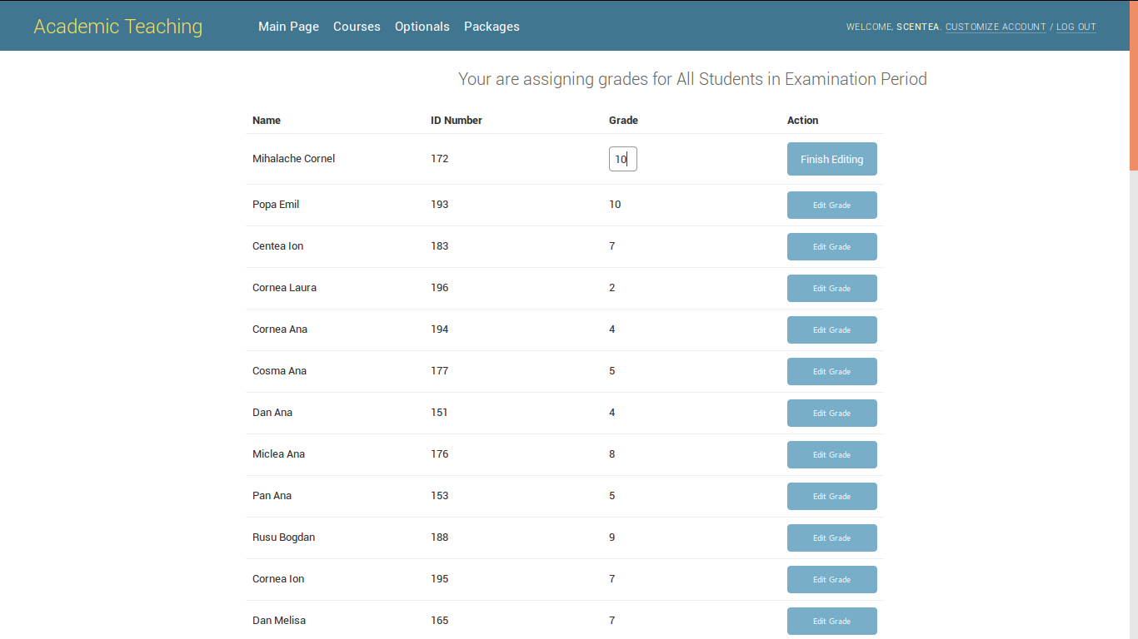

If you are chief of department you can also add optional packages and to see which ones belong to you

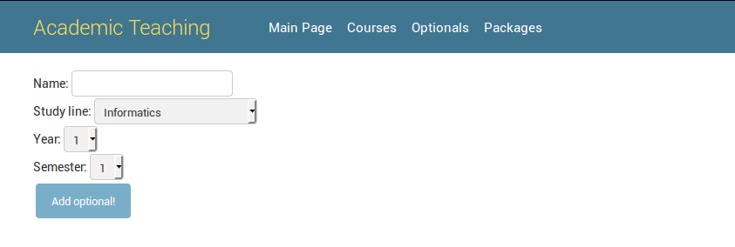

Moving forward to the students part, after showing the main page you can select the ‘grades’ tab, you can notice the the courses from the current semester, the number of credits for each course and the grades received.

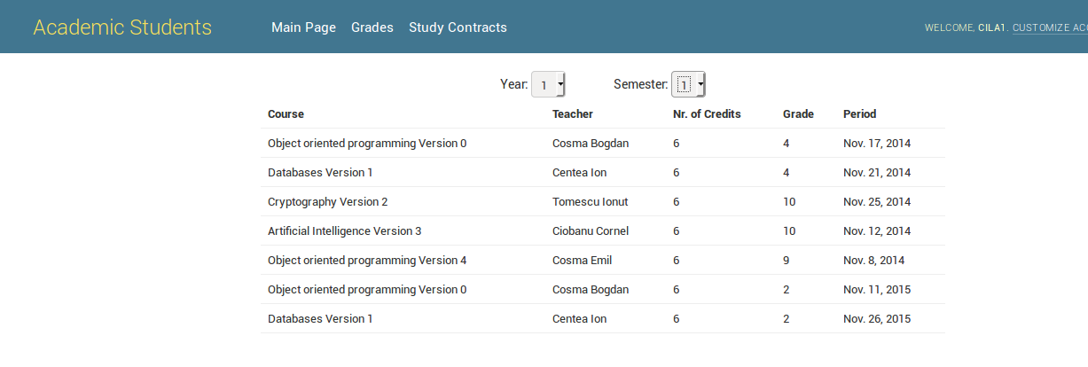Also you can check the study contracts by clicking the contracts tab

